**Лабораторна робота №2**

**Тема: Породжувальні шаблони**

**Мета роботи:** навчитися реалізовувати породжувальні шаблони проєктування

**Хід Роботи**

**Репозиторій:** https://github.com/Oleksandr-Nagal/KPZ

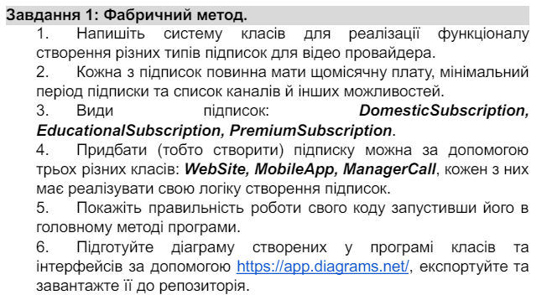

**Код:**

using System;

using System.Collections.Generic;

public abstract class Subscription

{

public decimal MonthlyFee { get; protected set; }

public int MinPeriod { get; protected set; }

public List<string> Channels { get; protected set; }

}

public class DomesticSubscription : Subscription

{

public DomesticSubscription()

{

MonthlyFee = 10;

MinPeriod = 1;

Channels = new List<string> { "Domestic Channels" };

}

}

public class EducationalSubscription : Subscription

{

public EducationalSubscription()

{

MonthlyFee = 20;

MinPeriod = 3;

Channels = new List<string> { "Educational Channels" };

}

}

public class PremiumSubscription : Subscription

{

public PremiumSubscription()

{

MonthlyFee = 30;

MinPeriod = 6;

Channels = new List<string> { "Premium Channels" };

}

}

public abstract class SubscriptionCreator

{

public abstract Subscription CreateSubscription();

}

public class WebSite : SubscriptionCreator

{

public override Subscription CreateSubscription()

{

Console.WriteLine("Creating subscription through website...");

Console.WriteLine("Please choose the type of subscription:");

Console.WriteLine("1. Domestic");

Console.WriteLine("2. Educational");

Console.WriteLine("3. Premium");

int choice = int.Parse(Console.ReadLine());

switch (choice)

{

case 1:

return new DomesticSubscription();

case 2:

return new EducationalSubscription();

case 3:

return new PremiumSubscription();

default:

throw new ArgumentException("Invalid choice");

}

}

}

public class MobileApp : SubscriptionCreator

{

public override Subscription CreateSubscription()

{

Console.WriteLine("Creating subscription through mobile app...");

Console.WriteLine("Please choose the type of subscription:");

Console.WriteLine("1. Domestic");

Console.WriteLine("2. Educational");

Console.WriteLine("3. Premium");

int choice = int.Parse(Console.ReadLine());

switch (choice)

{

case 1:

return new DomesticSubscription();

case 2:

return new EducationalSubscription();

case 3:

return new PremiumSubscription();

default:

throw new ArgumentException("Invalid choice");

}

}

}

public class ManagerCall : SubscriptionCreator

{

public override Subscription CreateSubscription()

{

Console.WriteLine("Creating subscription through manager call...");

Console.WriteLine("Please choose the type of subscription:");

Console.WriteLine("1. Domestic");

Console.WriteLine("2. Educational");

Console.WriteLine("3. Premium");

int choice = int.Parse(Console.ReadLine());

switch (choice)

{

case 1:

return new DomesticSubscription();

case 2:

return new EducationalSubscription();

case 3:

return new PremiumSubscription();

default:

throw new ArgumentException("Invalid choice");

}

}

}

class Program

{

static void Main(string[] args)

{

SubscriptionCreator website = new WebSite();

Subscription subscription1 = website.CreateSubscription();

Console.WriteLine("Мiсячна плата: " + subscription1.MonthlyFee);

Console.WriteLine("Мiнiмальний перiод: " + subscription1.MinPeriod );

Console.WriteLine(string.Join(", ", subscription1.Channels ) + '\n');

SubscriptionCreator mobileApp = new MobileApp();

Subscription subscription2 = mobileApp.CreateSubscription();

Console.WriteLine("Мiсячна плата: " + subscription2.MonthlyFee);

Console.WriteLine("Мiнiмальний перiод: " + subscription2.MinPeriod);

Console.WriteLine(string.Join(", ", subscription2.Channels) + '\n');

SubscriptionCreator managerCall = new ManagerCall();

Subscription subscription3 = managerCall.CreateSubscription();

Console.WriteLine("Мiсячна плата: " + subscription3.MonthlyFee);

Console.WriteLine("Мiнiмальний перiод: " + subscription3.MinPeriod);

Console.WriteLine(string.Join(", ", subscription3.Channels));

}

}

**Результат Виконання:**

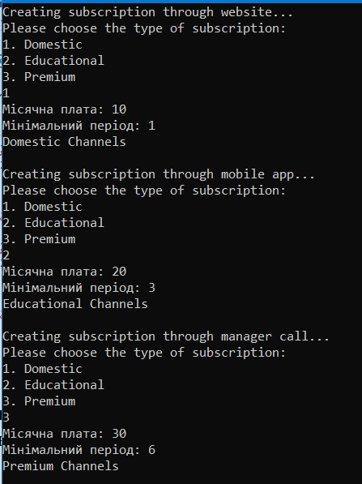

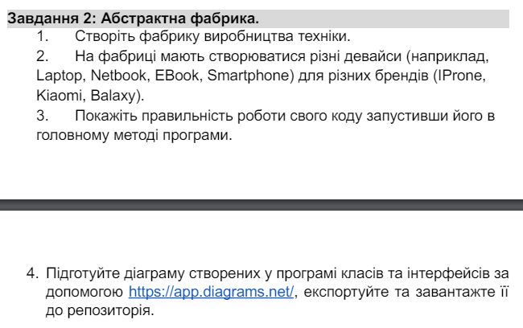

**Код:**

using System;

public abstract class Device

{

public string Model { get; set; }

public string Brand { get; set; }

public abstract void DisplayInfo();

}

public class Laptop : Device

{

public override void DisplayInfo()

{

Console.WriteLine($"Laptop: {Brand} {Model}");

}

}

public class Netbook : Device

{

public override void DisplayInfo()

{

Console.WriteLine($"Netbook: {Brand} {Model}");

}

}

public class EBook : Device

{

public override void DisplayInfo()

{

Console.WriteLine($"EBook: {Brand} {Model}");

}

}

public class Smartphone : Device

{

public override void DisplayInfo()

{

Console.WriteLine($"Smartphone: {Brand} {Model}\n");

}

}

public abstract class DeviceFactory

{

public abstract Laptop CreateLaptop();

public abstract Netbook CreateNetbook();

public abstract EBook CreateEBook();

public abstract Smartphone CreateSmartphone();

}

public class IPhoneFactory : DeviceFactory

{

public override Laptop CreateLaptop()

{

return new Laptop { Brand = "IPhone", Model = "IPhone Laptop" };

}

public override Netbook CreateNetbook()

{

return new Netbook { Brand = "IPhone", Model = "IPhone Netbook" };

}

public override EBook CreateEBook()

{

return new EBook { Brand = "IPhone", Model = "IPhone EBook" };

}

public override Smartphone CreateSmartphone()

{

return new Smartphone { Brand = "IPhone", Model = "IPhone Smartphone" };

}

}

public class XiaomiFactory : DeviceFactory

{

public override Laptop CreateLaptop()

{

return new Laptop { Brand = "Xiaomi", Model = "Xiaomi Laptop" };

}

public override Netbook CreateNetbook()

{

return new Netbook { Brand = "Xiaomi", Model = "Xiaomi Netbook" };

}

public override EBook CreateEBook()

{

return new EBook { Brand = "Xiaomi", Model = "Xiaomi EBook" };

}

public override Smartphone CreateSmartphone()

{

return new Smartphone { Brand = "Xiaomi", Model = "Xiaomi Smartphone" };

}

}

public class GalaxyFactory : DeviceFactory

{

public override Laptop CreateLaptop()

{

return new Laptop { Brand = "Galaxy", Model = "Galaxy Laptop" };

}

public override Netbook CreateNetbook()

{

return new Netbook { Brand = "Galaxy", Model = "Galaxy Netbook" };

}

public override EBook CreateEBook()

{

return new EBook { Brand = "Galaxy", Model = "Galaxy EBook" };

}

public override Smartphone CreateSmartphone()

{

return new Smartphone { Brand = "Galaxy", Model = "Galaxy Smartphone" };

}

}

class Program

{

static void Main(string[] args)

{

DeviceFactory factory1 = new IPhoneFactory();

Device laptop1 = factory1.CreateLaptop();

Device netbook1 = factory1.CreateNetbook();

Device ebook1 = factory1.CreateEBook();

Device smartphone1 = factory1.CreateSmartphone();

laptop1.DisplayInfo();

netbook1.DisplayInfo();

ebook1.DisplayInfo();

smartphone1.DisplayInfo();

DeviceFactory factory2 = new XiaomiFactory();

Device laptop2 = factory2.CreateLaptop();

Device netbook2 = factory2.CreateNetbook();

Device ebook2 = factory2.CreateEBook();

Device smartphone2 = factory2.CreateSmartphone();

laptop2.DisplayInfo();

netbook2.DisplayInfo();

ebook2.DisplayInfo();

smartphone2.DisplayInfo();

DeviceFactory factory3 = new GalaxyFactory();

Device laptop3 = factory3.CreateLaptop();

Device netbook3 = factory3.CreateNetbook();

Device ebook3 = factory3.CreateEBook();

Device smartphone3 = factory3.CreateSmartphone();

laptop3.DisplayInfo();

netbook3.DisplayInfo();

ebook3.DisplayInfo();

smartphone3.DisplayInfo();

}

}

**Результат Виконання:**

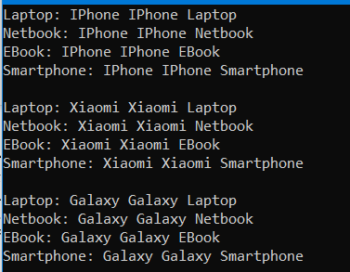

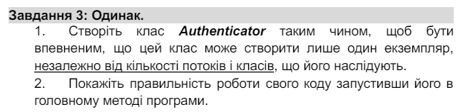

**Код:**

public class Authenticator

{

private static Authenticator instance;

private Authenticator() { }

public static Authenticator GetInstance()

{

if (instance == null)

{

instance = new Authenticator();

}

return instance;

}

}

class Program

{

static void Main(string[] args)

{

Authenticator authenticator1 = Authenticator.GetInstance();

Authenticator authenticator2 = Authenticator.GetInstance();

Console.WriteLine(authenticator1 == authenticator2); // Виведе "True", якщо обидва об'єкти є посиланням на один і той же екземпляр

}

}

**Результат Виконання:**



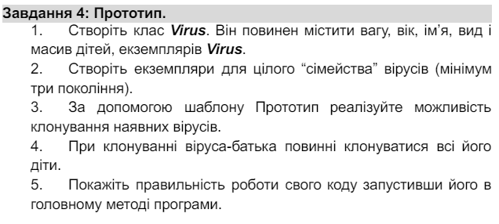

**Код:**

using System;

using System.Collections.Generic;

public class Virus : ICloneable

{

public double Weight { get; set; }

public int Age { get; set; }

public string Name { get; set; }

public string Type { get; set; }

public List<Virus> Children { get; set; }

public Virus(double weight, int age, string name, string type)

{

Weight = weight;

Age = age;

Name = name;

Type = type;

Children = new List<Virus>();

}

public object Clone()

{

Virus clone = new Virus(this.Weight, this.Age, this.Name, this.Type);

foreach (var child in Children)

{

clone.Children.Add((Virus)child.Clone());

}

return clone;

}

public void DisplayInfo()

{

Console.WriteLine($"Name: {Name}, Type: {Type}, Weight: {Weight}, Age: {Age}");

}

}

class Program

{

static void Main(string[] args)

{

Virus grandparentVirus = new Virus(2.5, 1, "Grandparent Virus", "A");

Virus parentVirus1 = new Virus(1.8, 2, "Parent Virus 1", "B");

Virus parentVirus2 = new Virus(2.0, 2, "Parent Virus 2", "C");

grandparentVirus.Children.Add(parentVirus1);

grandparentVirus.Children.Add(parentVirus2);

Virus childVirus1 = new Virus(1.2, 1, "Child Virus 1", "D");

Virus childVirus2 = new Virus(1.0, 1, "Child Virus 2", "E");

parentVirus1.Children.Add(childVirus1);

parentVirus1.Children.Add(childVirus2);

Virus grandChildVirus1 = new Virus(0.8, 1, "Grandchild Virus 1", "F");

Virus grandChildVirus2 = new Virus(0.7, 1, "Grandchild Virus 2", "G");

childVirus1.Children.Add(grandChildVirus1);

childVirus2.Children.Add(grandChildVirus2);

Virus clonedGrandparent = (Virus)grandparentVirus.Clone();

Virus clonedParent1 = (Virus)parentVirus1.Clone();

Console.WriteLine("Cloned Grandparent Virus:");

clonedGrandparent.DisplayInfo();

Console.WriteLine("\nCloned Parent Virus 1:");

clonedParent1.DisplayInfo();

}

}

**Результат Виконання:**

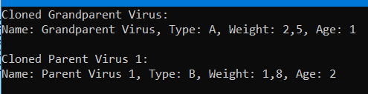

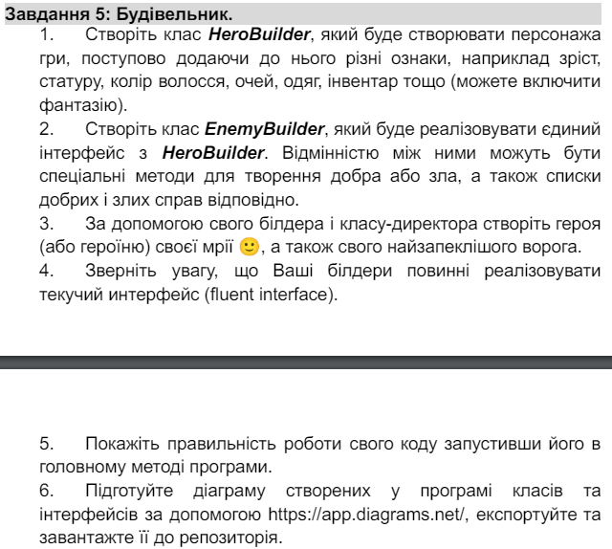

**Код:** using System;

using System.Collections.Generic;

// Клас для створення героїв

public class HeroBuilder

{

protected string Name;

protected string Gender;

protected int Height;

protected string HairColor;

protected string EyeColor;

protected string Clothing;

protected List<string> Inventory;

public HeroBuilder SetName(string name)

{

Name = name;

return this;

}

public HeroBuilder SetGender(string gender)

{

Gender = gender;

return this;

}

public HeroBuilder SetHeight(int height)

{

Height = height;

return this;

}

public HeroBuilder SetHairColor(string hairColor)

{

HairColor = hairColor;

return this;

}

public HeroBuilder SetEyeColor(string eyeColor)

{

EyeColor = eyeColor;

return this;

}

public HeroBuilder SetClothing(string clothing)

{

Clothing = clothing;

return this;

}

public HeroBuilder AddToInventory(string item)

{

if (Inventory == null)

{

Inventory = new List<string>();

}

Inventory.Add(item);

return this;

}

public Hero Build()

{

return new Hero(Name, Gender, Height, HairColor, EyeColor, Clothing, Inventory);

}

public Enemy BuildEnemy(List<string> evilDeeds)

{

return new Enemy(Name, Gender, Height, HairColor, EyeColor, Clothing, Inventory, evilDeeds);

}

}

// Клас героя

public class Hero

{

public string Name { get; }

public string Gender { get; }

public int Height { get; }

public string HairColor { get; }

public string EyeColor { get; }

public string Clothing { get; }

public List<string> Inventory { get; }

public Hero(string name, string gender, int height, string hairColor, string eyeColor, string clothing, List<string> inventory)

{

Name = name;

Gender = gender;

Height = height;

HairColor = hairColor;

EyeColor = eyeColor;

Clothing = clothing;

Inventory = inventory;

}

public void ShowInfo()

{

Console.WriteLine($"Name: {Name}, Gender: {Gender}, Height: {Height}, Hair Color: {HairColor}, Eye Color: {EyeColor}, Clothing: {Clothing}");

Console.WriteLine("Inventory:");

foreach (var item in Inventory)

{

Console.WriteLine("- " + item);

}

}

}

// Клас ворога

public class Enemy : Hero

{

public List<string> EvilDeeds { get; }

public Enemy(string name, string gender, int height, string hairColor, string eyeColor, string clothing, List<string> inventory, List<string> evilDeeds)

: base(name, gender, height, hairColor, eyeColor, clothing, inventory)

{

EvilDeeds = evilDeeds;

}

public void ShowEvilDeeds()

{

Console.WriteLine("Evil Deeds:");

foreach (var deed in EvilDeeds)

{

Console.WriteLine("- " + deed);

}

}

}

class Program

{

static void Main(string[] args)

{

HeroBuilder heroBuilder = new HeroBuilder();

Hero hero = heroBuilder

.SetName("Hero")

.SetGender("Male")

.SetHeight(180)

.SetHairColor("Brown")

.SetEyeColor("Blue")

.SetClothing("Armor")

.AddToInventory("Sword")

.AddToInventory("Shield")

.Build();

Console.WriteLine("Hero:");

hero.ShowInfo();

Console.WriteLine();

List<string> evilDeeds = new List<string> { "Destroyed the village", "Stole the king's treasure" };

Enemy enemy = heroBuilder

.SetName("Enemy")

.SetGender("Female")

.SetHeight(160)

.SetHairColor("Black")

.SetEyeColor("Red")

.SetClothing("Dark Robe")

.AddToInventory("Magic Staff")

.BuildEnemy(evilDeeds);

Console.WriteLine("\nEnemy:");

enemy.ShowInfo();

enemy.ShowEvilDeeds();

}

}

**Результат Виконання:**

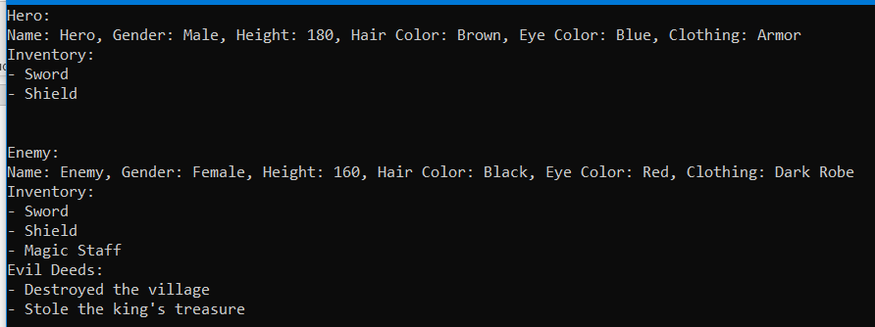

**Висновок:** У ході виконання лабораторної роботи я навчився реалізовувати породжувальні шаблони проєктування.